Longwood University

Student Government Association

2018-2019 Session

Senate Resolution Number: 01-2018.19

Introduced on: 03/12/2019

Description: This resolution expresses the opinion of the student body in regards to altering a policy in the Student Handbook. This resolution calls for the dismissal of the 12 required Longwood credits to be apart of a Greek organization.

Authors: FSL Rep Jessica Savas, Vice President Catherine Swinsky
Sponsors: Junior Class President Haleigh Pannell, Webmaster Mason Patrick

WHEREAS, This resolution gives all Freshman the opportunity to join a greek organization within the Office of Fraternity and Sorority Life during their first semester if they so please. Freshman will still have the choice to join second semester, if they feel as if they not ready to join a fraternity or sorority their first semester. FSL also does not have the intention of bashing other organizations, we simply want fair treatment for all students and all organizations.

WHEREAS, Organizations on campus should have the right to take freshman first semester, and to not discriminate against Greek students. Michael Overing, a First Amendment expert and adjunct professor of Annenberg School for Communication and lawyer, said that by deferring rush Colleges and Universities are violating the students’ rights to join organizations on campus.

WHEREAS, Tri-Council (IFC, CPC, NPHC) and Gamma Rho Lambda all do not support deferred recruitment.

WHEREAS, According to Peter J. Collier, PhD: With this new generation, student success is directly correlated with the amount of peer mentorship they recieve. Regardless of the change from LSEM to the new coaching group model, the opportunity for additional peer mentorship through Greek life allows for higher success with students earlier on in their Freshman year.

WHEREAS, Greek life membership, specifically IFC membership, has continually declined. From Spring of 2016 IFC Membership has declined from 307 IFC members to around 220 IFC Members Spring of 2019.

WHEREAS, CPC Membership has gone from 656 members in Spring of 2016 to around 527 CPC Members in Spring of 2019.

WHEREAS, NPHC has gone from 43 members in Spring of 2016 to 27 Fall of 2018.

WHEREAS, All Greek numbers have gone from 963 members in Spring of 2016 to 569 Members Fall of 2018. Allowing first semester freshman will increase Greek Numbers in every council. This is a very rapid decline considering in Spring of 2016 Longwood had 4,088 students on campus, and as of Fall 2018 Longwood had 4,044 students on campus.

WHEREAS, 49% of women that go through formal CPC recruitment are single preferencing on the final day of recruitment. This has increased since past years and is showing that premade judgements of chapters are being made during the fall semester before formal recruitment begins. With the four week adjustment period in the fall, women are able to become educated about their Greek options without having an entire semester to make false judgements about an organization before formal recruitment.

WHEREAS, There are issues with Greek women living in Stubbs Hall due to the fact that women are signing leases to live off campus during the fall semester before CPC formal recruitment. With these women signing leases in the fall, they are not living in Stubbs Hall, which means that the halls are not being filled, or non Greek students are living on the chapter halls. Having recruitment during the fall semester would help with the removal of the lease signing in the fall and would increase the amount of Greek women living in Stubbs Hall. (Stubbs hall report is at the bottom)

WHEREAS, Since Spring of 2016, the number of men getting more than 1 bid from our member fraternities has decreased. This past Spring of 2019, not one single man got more than 1 bid. This is showing that freshman are only getting to know one organization, and sticking with them throughout the fall semester.

WHEREAS, Only 50 men went through Spring rush in 2019. This number is continuing to decrease due to freshman not making the required 2.5 GPA.

WHEREAS, In order to educate freshman on all of the choices in the Greek community a Greek orientation system is proposed. This system include introductions of all councils and Gamma Rho Lambda over summer orientation. In the first week of class, Tri-Council and GRL would host an information session, where all organizations would present on who they are, their values, etc. In order for any student at Longwood University to go Greek their first semester, they would be required to go to these sessions. After the Greek orientation system closes, a reception would be held afterwards for these students to speak to the groups they are interested in.

WHEREAS, IFC and CPC are proposing bid day to be during the 4th week of class, allowing a month for students to research and to get to know all of our respective organizations. This also allows time for the up to 6 week New Member education process to take place, and finished by the 10th week of classes.

WHEREAS, Many Greek organizations vote on executive roles in the fall, which inhibits new members from holding leadership positions until their second year.

WHEREAS, Some organizations are allowed to take first semester freshman. In certain, not all, organizations, there are social events, Big/littles, and a time commitment. While not all organizations are the same as Greek life, in certain teams there are similarities. This is unfair to the Greek community, and the rest of the student body who would’ve like to have gone Greek their first semester but weren’t allowed.
00
WHEREAS, Longwood Greek GPAs in both cumulative and term, have always been higher than Longwood Non-Greek GPAs. In Spring of 2016 the Greek Term GPA was 2.954, and the Non-Greek GPA was 2.947. In Fall of 2018 the Greek Term GPA was 3.08, and the Non-Greek Term GPA was 2.91.

WHEREAS, From Spring of 2016 to Fall of 2018 the Longwood Greek Cumulative GPA has gone from from 2.928 to 3.06. From Spring of 2016 to Fall of 2018 the Longwood Non-Greek GPA has gone from 2.91 to 2.87. This will increase the grades of those who are able to go Greek first semester freshman year. Leading to higher Longwood Grades and Retention rates. (Grade Graphs at the bottom. Greek Grades are higher 83% of the time from Spring 2016-Fall 2018)

WHEREAS, The Retention rate in Greek Life is higher. Longwood's overall retention rate is 81% for the whole population. For Greeks, it is 90%.

WHEREAS, Graduation rate in Greek life is higher. At Longwood the overall 4-year grad rate is 48%. It’s higher for Greeks, at 58%.

WHEREAS, Unrecognized groups are recruiting first semester students during the fall and taking these prospective Greek students away from the recruiting process in the spring semester. This is an issue for IFC, CPC, NPHC, and GRL and is currently putting our first semester students into non-advised situations. Students joining these organizations during the fall are ultimately taking away from recruitment numbers in the spring. With the opportunity to recruit during the fall semester, we would be able to educate the Freshman on the difference between on-campus and off-campus greek organizations.

WHEREAS, When joining a Greek organization, it opens up an alumni base that can donate money in order to pay for chapter dues. It opens up a National Organization, that provides numerous scholarships every year. It opens up the ability to do fundraisers to help the financial costs. Joining a Greek organization provides numerous areas for financial support. This alumni base also opens up an extensive networking base, opening up new opportunities for future internships and jobs for students.

WHEREAS, If our Greek organizations continue to lose membership at any rate, our membership dues will continue to increase. Therefore, our chapters will die due to financial costs. Allowing the Freshman to increase chapter numbers will lower dues.

THEREFORE, BE IT RESOLVED that the Student Government Association encourages an active discussion and cooperative partnership with Longwoods Greek Community, in an effort to alter the language in the 2020-2021 Student Handbook and in future handbooks, in regards to 12 minimum credits to join a greek organization.

Proposed Language:

Longwood Handbook- New Member Education Processes

All new members must have the following:
1. First semester freshman must have a minimum cumulative high school Grade Point Average (GPA) of X. All other students must have a minimum cumulative Longwood Grade Point Average (GPA) of 2.5. Please note that individual RSOs may require a higher GPA or a specific subset of additional courses.

RSOs under the Office of Fraternity and Sorority Life must:
1. communicate and ensure their procedures are worked in accordance with office policies;
2. all New Members must complete a New Member Intake Packet and required FERPA paperwork

Data and Supporting Statements
Continued Data:
Stubbs Hall housing report: 2015-2018
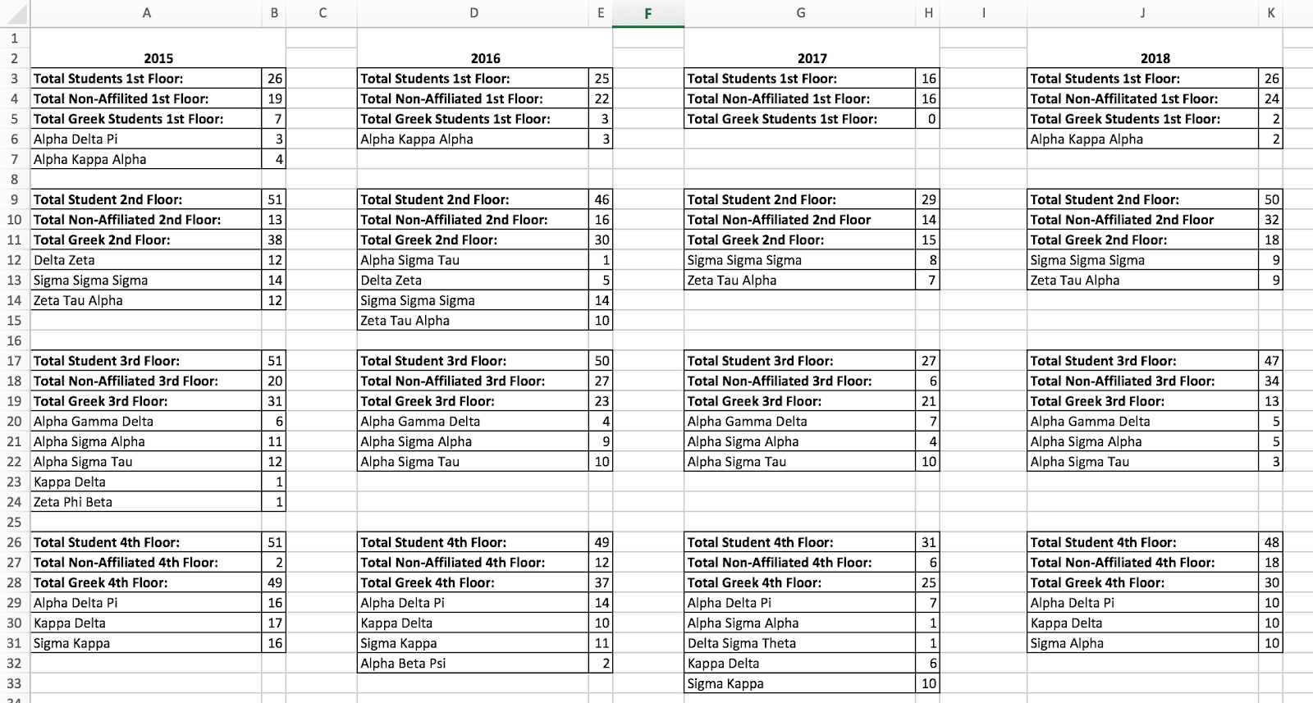

GPA Reports:
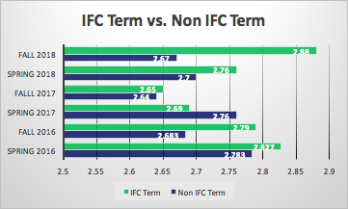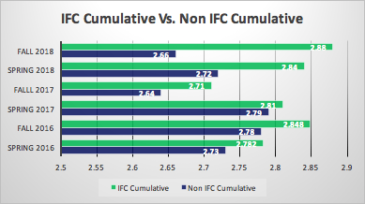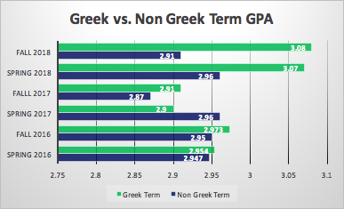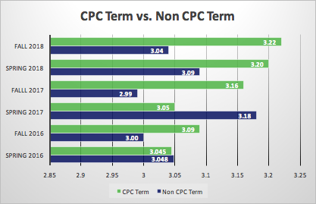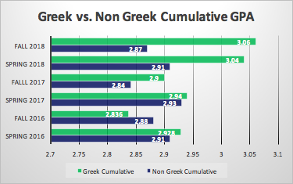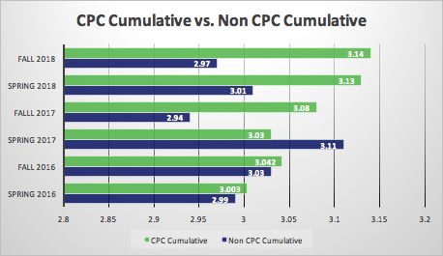

According to NIC data:
- Over 85% of the student leaders on some 730 campuses are involved in the Greek community
- The Greek system is the largest network of volunteers in the United States, with members donating over 10 million hours of volunteer service each year.
- As Alumni, Greeks give approximately 75% of all money donated to universities
A United States Government study shows that over 70% of all those who join a fraternity/sorority graduate, while under 50% of all non-fraternity/sorority persons graduate.

A Quasi-Experimental Analysis of Fraternity or Sorority Membership and College Student Success was done in 2017 by Nicholas A. Bowman, Joshua M. Holmes. Published by Johns Hopkins University Press (Journal of College Student Development, Volume 58, Number 7, October 2017, pp. 1018-1034)
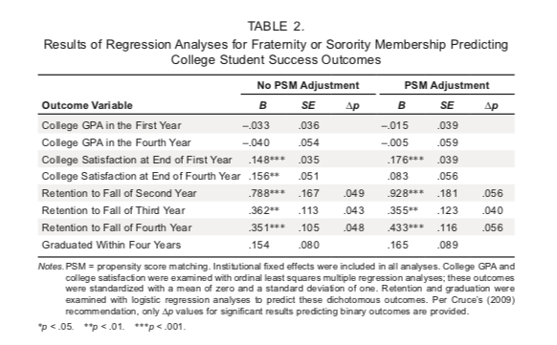

“Table 2 contains results for the full sample. Analyses without the propensity score adjustment show that fraternity/sorority membership predicts greater college satisfaction (at the end of the first and fourth years) as well as greater retention (to the Fall terms of the second, third, and fourth years). Among female students, sorority membership is positively related to first-year GPA, first-year satisfaction, retention to all three years, and college graduation. The relationships for retention and graduation actually increase over time. In contrast, among male students, positive relationships are evident for first-year college satisfaction and retention to the second year.”

In 2016-2017 TheAFA/Benchworks Fraternity/Sorority Assessment was done. The assessment measures concepts such as satisfaction with chapter programming, housing, and safety; role of interactions with other members and leaders in skill development; measures of organizational engagement and leadership; measures of learning related to practical skills, interpersonal and intrapersonal relationships, and healthy behaviors. The data in this note are from 19,852 college students from 24 institutions in the United States.
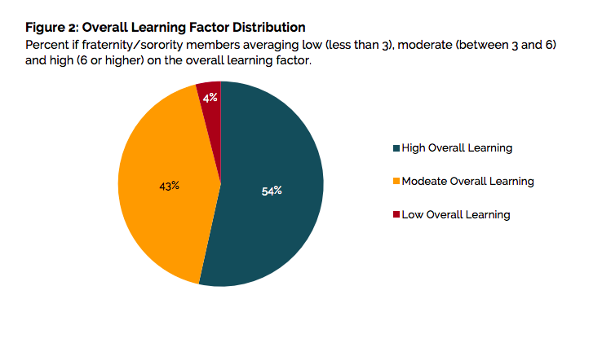
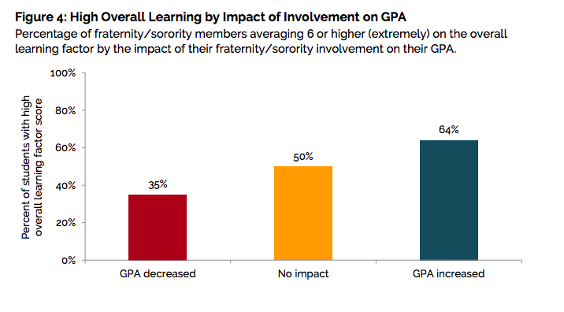

CPC Position:
The National Panhellenic Conference (NPC), one of the world’s largest organizations advocating for women, is the umbrella group for 26 inter/national sororities. NPC endorses primary recruitment occurring in the fall academic term because it best accomplishes the following:
- Retention: Engages women quickly as first-year students so they continue in college.
- Acclimation: Provides women an early opportunity to adapt to the demands of campus life, including academic, social, cultural and service components, by quickly affiliating with a supportive subset of female students.
- Academic success: Encourages women to engage in chapter academic study and scholarship groups immediately.
- Mentoring: Provides female mentoring for women via chapter members and alumnae.
- Objectivity: Allows all participants the best opportunity to be considered objectively
- and to make their choices clearly without the subjective influences of detractors.
- Scheduling: Offers fewer disruptions caused by inclement weather conditions.
- Fairness: Enables NPC member organizations to recruit during the same time period that other campus organizations are allowed to recruit new members. Deferred recruitment is an inequitable application of student policy because other student organizations – such as intercollegiate athletics, school-sanctioned clubs and others are free to recruit, select and enroll new members at any time.
- Sorority programming and expectations follow the missions of higher education institutions by fostering a spirit of sisterhood, which serves as a safety net for young women as they acclimate to a college/university environment.
Studies indicate that student retention is enhanced by membership in a sorority, where mutually supportive members sharing common interests and values leads to greater collegiate satisfaction. NPC believes that there is no substitute for the enrichment that sororities offer young women as part of the college/university experience, and this enrichment is most beneficial early in the academic year. With the aim of providing first- year women a sound base for educational success throughout college, NPC asserts that deferred recruitment, or second academic term recruitment, is not in the best interests for the health and welfare of a sound sorority community and its members. [Adopted: 2014]
This relates to Longwood University’s campus by wanting these women to be citizen leaders on campus and making an impact right away. These programs would be beneficial for these women because they are gaining an academic and social support system during their first semester. By having this support system, their love for Longwood could increase by seeing other members involved and happy with the university and can potentially motivate these members to be involved in other campus organizations as well, which is something that Greek organizations motivate their members to do.

NIC Position:
Deferred Recruitment: Potential new members are required by the campus to wait a certain amount of time or complete a designated number of credits before being allowed to join a fraternity.
- Rationale: This allows the student(s) to become acclimated to the college setting allowing a less stressful transition from high school while promoting a safer new member experience.
The NIC does not support deferred recruitment as it is an inequitable application of student policy and an infringement on the associational rights of students and organizations. Independent research shows the following: o Fraternity members exhibit higher levels of growth, learning, and development than non-fraternity men, and the difference in growth is most pronounced during a man’s first semester of college. o Fraternity members have higher campus retention rates than non-fraternity men o The graduation rate among fraternity men is higher than non-fraternity men. o A successful fraternity experience provides men with a sense of community and support network that aids in a successful transition to the collegiate experience.

Even though personal stories aren’t statistics, these are real life stories taken from our greek students at Longwood University. Many of these students we received statements from were one decision away from leaving Longwood, hurting the retention rate. These are just a couple of the testimonies.

Testimonies:

“Being Greek kept me at Longwood because it offered opportunities and friendships that no other type of organization can offer. If there were no Greek system at Longwood, I would have attended elsewhere or transferred. It has been integral in my experience here and is one of the facets of Longwood that draws students here and keeps them here” -Matt Crow

“When I first came to Longwood I wanted to transfer. I was miserable here. I was used to having a group of girl friends from high school, and I didn't have that here. I planned on transferring my sophomore year since I missed the application deadline for spring of my freshman year, but then my mom told me I should consider going Greek. I ended up going Greek, and realized Longwood was the place for me. It gave me the group of friends I needed in order to enjoy being here. I never thought about transferring again after bid day.” -Madison Lindsay

“I had no connections at Longwood before recruitment and I felt that the only way I could be happy was to leave. I wanted so badly to return home and attend school closer to my family. Going through recruitment helped me find my second family as well as my home away from home. After going through recruitment, I was surrounded by so many opportunities and connections that have shaped me into the person I am today.”
-Claudia Hayes

“When I came to Longwood I had no idea what I wanted to with my time in college I just knew that I wanted the full college experience so I wouldn't regret what everyone calls "the best four years of your life". During my first semester I had doubts about staying in Farmville because there was not much to do here and it seemed like all of my friends were having the time of their lives at other bigger schools and I felt like I was missing out. I worked very hard to have a good GPA so that I could transfer anywhere I wanted to, I even filled out some transfer apps just in case. I joined Greek life because I thought it would possibly give me a reason to stay. Looking back on it, it was the best choice I have made in my college career so far and in fact, made me realize that everyone else was missing out on the experience that I was having”
-Kent Wells

“When I came to Longwood I was so excited to meet new people and join different organizations and be involved. I wanted to be in Greek life since I knew what it was, but didn’t realize I was going to have to wait. While all my friends got bids at their schools as soon as they arrived, I had to wait to get involved bc of the fact that we have to have 12 credits and GPA at Longwood. The first weeks were fun, but I quickly started to feel like I didn’t belong at Longwood and debated transferring back home. I felt like I wouldn’t be able to enjoy my college career because I hadn’t found my “home away from home” yet. My mom encouraged me to stay and told me I would regret it and miss out on the opportunity to be in Greek life like I had always wanted. As soon as rush came I got excited because I knew I would be able to find my home. From the moment I got my bid I have felt such a welcoming place at Longwood and have made lasting friendships. My sorority has allowed me to get involved in so many other organizations too because of the people you meet through it. I truly believe that if it weren’t for jointing Greek life, I would not be at Longwood today. I have found my place and Longwood all because I rushed. I know a lot of people who felt the same way in their first semester at Longwood and some people didn’t stay dropped out because they didn’t feel like they were involved. Allowing recruitment to happen in the fall would allow more students to feel at home quicker and then to give back to the Farmville community faster as well.”
-Savannah Wright

“As NPHC president it is my responsibility to make the best decisions for my council and Tri-Council as a whole. Therefore, I feel it is in the best interest to move forward with the proposal as stated above. I believe the educational component will benefit Tri-Council and Gamma Rho Lambda as a whole. I also stand in solidarity with IFC, CPC, and GRL in taking deferred recruitment out of the student handbook though it will not effect NPHC. It is not my place to stand in opposition to something that is within the rights of these organizations.” -Norman Hurt

“Gamma Rho Lambda is in support of removing deferred recruitment for first semester freshmen. We want the opportunity to be available to all those who are interested in joining our siblinghood regardless of what semester of study they are in. GRL would benefit from the removal of deferred recruitment because as a multicultural based organization, which are always smaller by their nature, we could bring people into our family, provide leadership opportunities, and secure the longevity of our organization at a quicker pace. This semester half of our organization is graduating, and we only had one new member rush. We are the newest greek org on campus and as president I would really hate for us to die out at all let alone so soon because we couldn't include prospective members just because they are new to campus.” -Braden GRL President

“Greek life has been on a drastic decline over the years and extreme measures need to be taken in order to save the Greek community at Longwood. With a right system set to show that Greek life has a positive impact on first year students with organizations skills, good study habits and helpful advice. Longwood should entertain the possibility of allowing first semester students to go Greek”-Praise Nyambiya

References

https://nces.ed.gov/collegenavigator/?id=232566#retgrad),

https://digscholarship.unco.edu/cgi/viewcontent.cgi?referer=https://www.google.com/&httpsredir=1&article=1064&context=urj

https://www.sciencedirect.com/science/article/pii/S2214804314000147

https://futuresinitiative.org/rethinkhighered/2017/11/29/topic-increasing-student-retention-the-problem-of-greek-life/

https://muse.jhu.edu/article/673464/pdf​

https://www.uccs.edu/Documents/retention/2003%20Institutional%20Factors%20Affecting%20Student%20Retention.pdf​

http://www.umich.edu/~deltachi/rush/greek.html

https://greeks.unm.edu/become-a-member/parents/fun-stats.html

https://www.winthrop.edu/greeklife/default.aspx?id=24722

https://www.southwestern.edu/life-at-southwestern/student-organizations/greek-social/fraternities-at-su/why-go-greek/

https://osfl.ucdavis.edu/about

https://fsl.uiowa.edu/about-us/faq/

http://gcsu.orgsync.com/org/fsl/

https://stuorgs.oregonstate.edu/ifc

https://www.businessinsider.com/greek-life-benefits-2014-12

https://www.usatoday.com/story/college/2012/05/08/examining-the-benefits-of-greek-life/37392651/

http://miamistudent.net/data-shows-higher-retention-rates-among-greekaffiliated-students/

https://NICfraternity.org

Jud.horras@nicfraternity.org

https://www.npcwomen.org/

https://docs.google.com/document/d/1iNlcW5QvwrkjWzBYFfbdV-J-GqTdgbpxebO902RIIVU/edit?ts=5c89280f

“Why peer mentoring is an effective approach for promoting college student success”
Peter J. Collier, PhD

